**Chapter 1**

**Introduction**

Depression is a mood disorder that causes a persistent feeling of sadness and loss of interest. Also called major depressive disorder or clinical depression, it affects how you feel, think and behave and can lead to a variety of emotional and physical problems. You may have trouble doing normal day-to-day activities, and sometimes you may feel as if life isn't worth living.

More than just a bout of the blues, depression isn't a weakness and you can't simply "snap out" of it. Depression may require long-term treatment. But don't get discouraged. Most people with depression feel better with medication, psychotherapy or both.

Automatic detection of Depression can substantially improve the person’s quality of life. To achieve a high-quality model, we have to collect data from various Social media Platforms in a central server. However, sending the person’s raw data to this central server puts patient privacy at risk and consumes a significant amount of energy. To address these challenges, in this work, I have designed and evaluated a standard federated learning framework in the context of Depression detection using a deep learning-based approach, which operates across a cluster of machines.

This study examines the usage of data mining in psychology, zeroing in on depression, to identify users experiencing a low mood on social media platforms. This utilization of data mining has vast technical and social ramifications. The theories proffered by this study show that the proposed model is effective at discovering unconspicuous depression amongst online users and mitigating consequential suicides.

I suffer from depression, so I am on trial for death. It has nothing to do with anything special. I don't care about my departure. Zoufan posted a microblog on March 18th, 2012, which dropped a bomb in Sina Micro-blog. Then on March 19th, JiangNing Police confirmed that Zoufan had committed suicide. Zoufan, whose real name is MaJie, was a talented university student in Nanjing. Her suicide for depression left us with endless sorrow. Zoufan Tragedy resulted from depression has aroused extensive concern of the whole society in China.

The inferences made from Zoufan's micro-blog posts were alarmingly indicative of her severe desolation and despondency. Regrettably, not enough words of notice were heard until the ultimate update on her profile shouted out 'goodbye' aloud. This analysis had the beneficence their professionals inspired psychologists directly gave it.This research builds a model for the recognition of depressed users and their behavior through psychological criteria. It concludes that this model is viable and provides methods for supervising mental wellbeing on a large scale, decreasing the chances of further tragic situations similar to one occurred in Zoufan.

* 1. **MOTIVATION**

Mental depression can have a significant impact on an individual's quality of life and can also have broader social and economic consequences for a country. Here are some of the effects of mental depression:

* Depression can cause a person's disposition to become significantly diminished and can lead to overwhelming negativity, dejection, and self-condemnation. Besides this, it can generate physical health consequences such as weakness, sleeplessness and changes in hunger. Furthermore, depression may impede a persons ability to operate properly in professional or academic environment and cause unbalance among personal relations.
* Economic impact: Mental depression can have a significant economic impact on individuals and on society as a whole. It can lead to decreased productivity at work, increased absenteeism, and increased healthcare costs. According to the World Health Organization, depression is the leading cause of disability worldwide.
* Mental depression has far-reaching effects on an individual's social links, often resulting in distancing and alienation. Such intensified splitting off increases the seriousness of depressive manifestations and can prove harmful, often leading to elements such as abusers of substances, self injury and taking one's own life.
* The influence of mental depression can even stretch to future generations, since those with parents affected by this disorder are more inclined to develop their own mental well-being difficulties. This creates a prolonged struggle for both the suffering family and society alike as it promises a chain of psychological issues marking outcomes far-reaching in time.
  1. AIM

The main purpose of this venture is to identify clients' contemporary opinions so that a serious depression situation can be reacted to swiftly or businesses and services can expand according to customer preferences. The additional mission behind the project is introducing a feature in the App quoting phrases according to the sentiment analysis(Next Word Prediction).

* 1. OBJECTIVE
* To develop a Transformer based deep learning model for precise sentiment detection.
* Providing the public with a new keyboard application will allow the government and businesses to monitor customer satisfaction easily.
  1. SCOPE

The scope of this project encompasses the development and evaluation of a real-time sentiment detection system using deep learning techniques integrated into a keyboard interface. The project aims to achieve the following objectives:

1. Develop a deep learning model: Design and implement a sentiment detection model based on recurrent neural networks (RNNs) that can effectively capture the contextual information and sequential dependencies in user input.
2. Dataset acquisition and pre-processing: Gather a large-scale dataset of labelled textual data with sentiment annotations for training and evaluation purposes. Pre-process the dataset to ensure data quality and compatibility with the sentiment detection model.
3. Training and optimization: Train the sentiment detection model using the labelled dataset, optimizing its performance by adjusting hyperparameters, exploring different architectural variations, and employing techniques such as transfer learning and fine-tuning.
4. Integration with keyboard interface: Integrate the trained sentiment detection model into a keyboard interface, enabling users to express their sentiments in real-time while typing. Develop a user-friendly interface that seamlessly incorporates the sentiment detection functionality.
5. Real-time sentiment prediction: Enable the system to continuously process user input and generate sentiment predictions in real-time. Provide immediate feedback to users, allowing them to modify their expressions based on the detected sentiment.
6. Performance evaluation: Evaluate the accuracy and efficiency of the sentiment detection system through comprehensive performance metrics such as precision, recall, F1 score, and computational efficiency. Compare the performance of the system with existing sentiment analysis techniques.
7. User studies: Conduct user studies to assess the usability and user satisfaction of the real-time sentiment detection keyboard system. Gather feedback and insights from users to further improve the system's functionality and user experience.

The project's scope does not include the development of sentiment analysis models for languages other than the one used in the labelled dataset, as well as extensive integration with specific applications or platforms. However, the system's potential for various applications, such as personalised user experiences, sentiment-aware chat interfaces, customer feedback analysis, and sentiment-driven marketing strategies, can be explored in future research and development efforts.

**Chapter 2**

**Literature Survey**

The development of technology along with the demand of analyzing opinionated information has led to a new research topic in natural language processing and data mining named "opinion mining and sentiment analysis". Studies on this problem started from the 2000[3]. Just 101 articles on this subject were published in 2005, while almost 5,699 were published in 2015. This means that over a decade sentiment analysis has increased almost 50 times, making it one of the most quickly expanding fields of study in previous years [4].

Li et al. proposed the Sentiment-LDA model and Dependency-Sentiment-LDA. Unlike the previous models making assumption that the sentiments of the words in the document are all independent, this model views the sentiments of words as a Markov chain. Zhao et al. proposed a MaxEnt-LDA hybrid model to jointly discover both aspects and aspect-specific opinion words. They show that with a relatively small amount of training data, Max- Ent-LDA hybrid model can effectively identify aspect and opinion words simultaneously [6].

2.1 Background History

There are some existing models present following are the comparison between those models

(A) Lexicon Based Model -It employs frequent and explicit product features extraction involving Syntax Tree Based Classification-Design Syntactic Patterns [1]. (B) Word Alignment Model (Unsupervised)-It concerns with Word Co-occurrence Frequencies and Position of Words [1]

(C) Word Alignment Model (Semi-supervised) - It involves analysis of Formal and Informal Text Separately [1]

2.2 Related Work

﻿(Wenhao Zhang, Hua Xu, Wei Wan, 2012) proposes an expert system Weakness Finder by analyzing the customers reviews on the influential web communities with aspects-based sentiment analysis, it can help the cosmetic manufacturers to find the weakness of the products in order to improve their products. The Weakness Finder system can help to identify the features, and group the features into different aspects by using explicit and implicit features grouping methods, then judge the polarity of each sentence by using sentence-level sentiment analysis [5].

(Fu Xianghua, Liu Guo, Guo Yanyan, Wang Zhiqiang, 2013) proposed a multi-aspect sentiment analysis of Chinese social reviews based on LDA topic model and HowNet lexicon. Their method adopts trained LDA model to identify the local topic of the sliding windows, and then analyze the associated sentiment of these sliding windows with HowNet lexicon. The experiment results show that their method not only obtains good performance in topic identification, but also has good performance in the sentiment analysis [6].

(D. Mali, M. Abhyankar, P. Bhavarathi, K. Gaidhar, M.Bangare, 2016) proposed test model which will give direct result of sentiments. It will help users gather the best information about any particular product they desire, based on other customers reviews, and help in making a decision about any product [1].

(P.K. Kannan Hongshuang Alice Li, 2017)They focus on how this affects information acquisition with regard to quality and price, the search process, customer expectations, and the resulting implication for firms. After examining digital technologies' facilitation of customer-customer interactions through online media word-of-mouth, online reviews and ratings, and social media interactions .The emergence of platforms institutions created through digital innovations which facilitate customer-to-customer interactions for ideation in new product/service development, those that connect customers and sellers in platform-based markets and those that leverage two-sided markets for their revenue generation[10].

﻿

(Duc-HongPham, Anh-CuongLe,2018) proposed a new MCNN model for exploiting multiple word embeddings and one-hot character vectors in aspect-based sentiment analysis. Various models were developed with different combinations of input representations. The experimental results showed that the combination of Word2Vec word embeddings, GloVe word embeddings, and one-hot character vectors in the framework of the MCNN-based model achieved the best accuracy [2].

(Duc-Hong Pham, Anh-Cuong Le, 2018) proposed a novel multi-layer architecture for representing customer reviews. They observe that the overall sentiment for a product is composed from sentiments of its aspects, and in turn each aspect has its sentiments expressed in related sentences which are also the compositions from their words. This observation motivates to design a multiple layer architecture of knowledge representation for representing the different sentiment levels for an input text. This representation is then integrated into a neural network to form a model for prediction of product overall ratings. A multi-layer architecture for representation of customers' textual opinions with objective to aspect-based sentiment analysis is proposed and it used to represent learning techniques including word embeddings and compositional vector models to obtain the word, sentence, aspect-based paragraph, and higher aspect representation layers, which helps to enrich knowledge of the input through layers step by step. [3]

(Reinald Kim Amplayo, Seanie Lee, Min Song, 2018) this paper proposed two topic models extended from the state-of-the-art sentiment topic model ASUM to improve the extracting of aspects by incorporating product description into the topic model. In the SA-ASM, the review looks directly to the sentences of the product description to seek help for extracting aspects. This makes the model to work well on specific problems in Aspect-based Sentiment Analysis (ABSA) such as sentiment classification and aspect assignment [11].

﻿

2.3 Summary & Discussion

Sentiment Analysis

Sentiment analysis is a type of data mining that aims to determine the polarity of people's opinions about someone or something [2] Sentiment Analysis is also known as opinion extraction, opinion mining, effect analysis, sentiment mining, emotion analysis, review mining, etc. [7] Sentimental Analysis is necessary for producing companies to evaluate various reviews automatically provided by customer regarding product. The use of the classification of sentimental analysis as an efficient way of analyzing textual data from different online platforms. Opinion mining offers an accurate and dynamic view of customers in real-time and may have a huge impact on business decision-making. They also recognized potential areas for further research from the Business Intelligence research pond.[4]

Sentiment Classifications are as follows

A) Document-level: The Document-level uses the entire documents to categorize it into a positive or negative class as a simple information category [4]. A major problem observed while dealing at document level is at this layer not all sentences involving expression of opinions can be deemed as subjective sentences. Hence, accuracy of results is dependent on how closely each sentence is extracted and analyzed individually. This method, therefore, promotes the rate at which subjective sentences can be extracted for the purpose of SA over objective sentences that can be set aside [7].

B) Sentence level: In the Sentence level, the sentiment classification categorize any sentence as subjective or objective, and then it categorize into a positive, negative, or common class [4] .Consider an example someone brought chair online and posted comment, "Brought chair online but the leather of chair is not very good quality",this type of sentence shows negative sentiment.

C) Aspect or Feature level: This type of sentiment classification discusses the identification and extraction of item features from source data [4]. If some customer brought some shirt from E-commerce site and he put review that "color of the shirt is not same, but quality of cloth is good" for this kind of mix sentiments, aspect level will work better as compared to document level or sentence level.

There are various machine learning algorithms can be used to perform sentimental analysis of huge data like Naive Bayes, Support vector machine, and Maximum entropy classifier algorithms using these techniques, a large amount of data can be utilized to get optimized results and helpful for decision-making capability.

**Chapter 3**

**Proposed System Analysis and Design**

3.1 System Analysis

**What is Sentiment analysis?**

Sentiment analysis is the process of extracting subjective information from text, such as opinions, emotions, and attitudes. It is a type of natural language processing (NLP) that is used to understand the emotional tone of a piece of text. Sentiment analysis can be used in a variety of applications, such as:

* Customer feedback analysis: Sentiment analysis can be used to analyze customer feedback to identify areas where a company can improve its products or services.
* Social media monitoring: Sentiment analysis can be used to monitor social media to identify trends and opinions about a company or product.
* Market research: Sentiment analysis can be used to gather market research data by analyzing online reviews and forums.
* Product development: Sentiment analysis can be used to gather feedback from users to help develop new products and features.
* Risk management: Sentiment analysis can be used to identify potential risks by analyzing social media and news articles.

Sentiment analysis is a powerful tool that can be used to gain insights into the opinions and emotions of people. It is a valuable tool for businesses and organizations that want to understand their customers, track their brand reputation, and make better decisions.

Here are some of the benefits of using sentiment analysis:

* Improved customer service: Sentiment analysis can be used to identify customer complaints and issues. This information can then be used to improve customer service and resolve problems quickly.
* Increased brand awareness: Sentiment analysis can be used to track the online conversation about a brand. This information can be used to identify opportunities to increase brand awareness and improve brand reputation.
* Better decision-making: Sentiment analysis can be used to gather data and insights that can be used to make better decisions. For example, sentiment analysis can be used to identify which products are most popular or which marketing campaigns are most effective.

Overall, sentiment analysis is a powerful tool that can be used to gain insights into the opinions and emotions of people. It is a valuable tool for businesses and organizations that want to understand their customers, track their brand reputation, and make better decisions.

Here are some of the challenges of using sentiment analysis:

* Data quality: The quality of the data used for sentiment analysis is important. If the data is not accurate, the results of the analysis will be inaccurate.
* Interpretation: The results of sentiment analysis can be difficult to interpret. There is no single agreed-upon method for interpreting sentiment analysis results.
* Bias: Sentiment analysis models can be biased. This can be due to the way the model is trained or the data that is used to train the model.

Despite these challenges, sentiment analysis is a valuable tool that can be used to gain insights into the opinions and emotions of people. It is a valuable tool for businesses and organizations that want to understand their customers, track their brand reputation, and make better decisions.

**How are sentiments detected in a sentence?**

Detecting the sentiment of a sentence involves determining the underlying emotion or opinion expressed within the text. There are several methods for sentiment detection, ranging from traditional rule-based approaches to more advanced machine learning and deep learning techniques. Here are some common methods:

1. Lexicon-based methods: These methods rely on sentiment lexicons, which are dictionaries containing words and their associated sentiment scores. Each word in the sentence is matched against the lexicon, and the sentiment scores are aggregated to determine the overall sentiment of the sentence. Examples of lexicon-based methods include the AFINN-111 lexicon and the SentiWordNet lexicon.
2. Machine learning methods: Machine learning algorithms can be trained on labeled datasets to classify sentences into different sentiment categories. Features such as word frequency, n-grams, syntactic patterns, and part-of-speech tags can be extracted from the text and used as input to the classifier. Common machine learning algorithms for sentiment detection include Naive Bayes, Support Vector Machines (SVM), and Random Forests.
3. Deep learning methods: Deep learning techniques, especially neural networks, have shown promising results in sentiment analysis. Recurrent Neural Networks (RNNs), Long Short-Term Memory (LSTM) networks, and Convolutional Neural Networks (CNNs) are commonly used architectures for sentiment detection. These models learn the complex relationships between words and sentiments by considering the sequential or contextual information present in the text.
4. Hybrid approaches: Hybrid approaches combine multiple methods to leverage their strengths. For example, a hybrid approach may incorporate both lexicon-based methods for capturing general sentiment and machine learning or deep learning models for capturing more nuanced sentiments or contextual information.
5. Transfer learning: Transfer learning involves utilizing pre-trained models that were trained on large-scale sentiment analysis tasks. These models, such as BERT (Bidirectional Encoder Representations from Transformers) or GPT (Generative Pre-trained Transformer), have learned to understand language representations and can be fine-tuned on specific sentiment analysis tasks with smaller datasets.

The best method for detecting the sentiment of a sentence will depend on the specific application. For example, rule-based sentiment analysis is often used for tasks such as customer feedback analysis, where the goal is to quickly identify positive and negative feedback. Machine learning sentiment analysis is often used for tasks such as social media monitoring, where the goal is to identify trends and opinions about a company or product.

Here are some of the challenges of detecting sentiment in a sentence:

* Ambiguity: The meaning of a sentence can be ambiguous, and this can make it difficult to determine the sentiment. For example, the sentence "This movie was a blast" could be interpreted as either positive or negative sentiment.
* Subjectivity: Not all sentences express opinions or emotions. Some sentences are simply factual statements, and these sentences do not have a sentiment.
* Context: The sentiment of a sentence can be influenced by the context in which it is used. For example, the sentence "I hate Mondays" could be interpreted as negative sentiment, but it could also be interpreted as a joke.

Despite these challenges, sentiment analysis is a valuable tool that can be used to gain insights into the opinions and emotions of people. It is a valuable tool for businesses and organisations that want to understand their customers, track their brand reputation, and make better decisions.

3.1.1 Problem Definition

Real-time sentiment analysis plays a critical role in understanding and responding to user emotions and opinions in various applications. However, traditional sentiment analysis methods often struggle to capture the nuances and context of natural language, leading to suboptimal accuracy and limited real-time capabilities. The problem addressed in this research is to develop an efficient and accurate real-time sentiment analysis system using transformer-based models.

Transformers, such as the Bidirectional Encoder Representations from Transformers (BERT) and its variants, have demonstrated state-of-the-art performance in various natural language processing tasks, including sentiment analysis. These models excel at capturing long-range dependencies and contextual information in text, making them suitable for addressing the challenges of real-time sentiment analysis.

The goal is to design and implement a real-time sentiment analysis system that leverages transformer-based models to accurately detect sentiment in user input. The system should be capable of processing user input in real-time, providing immediate feedback on the sentiment conveyed by the text.

The problem encompasses several key aspects:

1. Real-time sentiment analysis: Developing a system that can analyze sentiment in real-time, enabling immediate feedback to users and timely responses in applications requiring sentiment-aware interactions.
2. Transformer-based models: Exploring and utilizing state-of-the-art transformer models, such as BERT and its variants, to capture the contextual information and complex relationships in user input for accurate sentiment analysis.
3. Model fine-tuning: Fine-tuning the transformer-based models on labeled sentiment analysis datasets to adapt them specifically for the task of real-time sentiment analysis.
4. Efficiency and scalability: Ensuring that the sentiment analysis system is efficient and scalable to handle real-time processing of user input, enabling its integration into applications and platforms with varying workloads.
5. Evaluation and benchmarking: Evaluating the performance of the real-time sentiment analysis system by comparing its accuracy, speed, and resource utilization against existing sentiment analysis methods and datasets. Performance metrics such as precision, recall, F1 score, and real-time latency should be considered.

* Problem: Real-time sentiment analysis is the task of extracting the sentiment of text in real time. This is a challenging task, as it requires the ability to process text quickly and accurately.
* Solution: Transformers are a type of neural network that have been shown to be effective for natural language processing tasks, such as sentiment analysis. Transformers can be used to process text in real time, and they have been shown to achieve high accuracy on sentiment analysis tasks.
* Approach: The approach to real-time sentiment analysis using transformers is to first train a transformer model on a large dataset of labeled text. The model can then be used to predict the sentiment of new text in real time.
* Evaluation: The performance of the model can be evaluated on a held-out dataset of labeled text. The accuracy of the model can be used to measure its performance.
* Deployment: The model can be deployed in a real-time application, such as a social media monitoring tool. The tool can be used to monitor social media for mentions of a company or product, and it can then be used to identify the sentiment of the mentions.

Here are some of the challenges of real-time sentiment analysis using transformers:

* Data: The model requires a large dataset of labeled text to train. This data can be difficult to obtain, and it can be expensive to collect.
* Computational resources: Transformers are computationally expensive to train and deploy. This can be a challenge for organizations with limited resources.
* Latency: Transformers can be slow to process text. This can be a challenge for applications that require real-time sentiment analysis.

Despite these challenges, real-time sentiment analysis using transformers is a promising approach for extracting the sentiment of text in real time. Transformers have been shown to be effective for natural language processing tasks, and they can be used to process text in real time.

3.1.2 Feasibility Study

 A feasibility study of sentiment analysis involves assessing the practicality and viability of implementing such a system. Here are some key aspects to consider in a feasibility study: Technical Feasibility:

1. Hardware Requirements: Evaluate the availability and compatibility of hardware components necessary for hand sign recognition, such as cameras or sensors capable of capturing hand movements accurately.

2. Software and Algorithms: Assess the availability of suitable software tools and algorithms for hand gesture detection, tracking, and recognition. Consider the complexity and computational requirements of these algorithms.

3.Real-Time Performance: Determine if the system can achieve real-time performance, processing hand gestures quickly enough to provide immediate responses in interactive applications. Real-time Conversion of Sign Language to Text and Speech by Using Gestures 4. Accuracy and Reliability: Evaluate the accuracy and reliability of hand sign recognition algorithms. Assess their performance in different environments, lighting conditions, and with variations in hand gestures.

Data Collection and Training: 1. Data Availability: Assess the availability of labeled hand gesture datasets for training and testing machine learning models. Consider the need for a diverse range of gestures and variations in hand shapes, sizes, and movements.

2. Annotation and Labeling: Determine the feasibility of annotating and labeling large amounts of hand gesture data accurately. This process can be time-consuming and require expertise in sign language or hand gestures

3.Training and Model Development: Evaluate the feasibility of training machine learning models using the available data and resources. Consider the time and computational requirements for training, as well as the expertise needed for model development.

3.1.3 Requirement Analysis

Requirement analysis is a crucial step in designing and developing a real-time sentiment analysis system using transformers. It involves identifying and documenting the functional and non-functional requirements of the system. Here are key aspects to consider in the requirement analysis of a sentiment analysis system using transformers:

Functional Requirements:

Real-time Sentiment Analysis:

* Real-time Processing: Specify the system's ability to analyze sentiment in real-time, providing immediate feedback on the sentiment conveyed by user input.
* Sentiment Classification: Define the required sentiment categories that the system should be able to classify and distinguish, such as positive, negative, neutral, or specific emotions.
* Contextual Understanding: Determine the system's capability to capture the contextual information and dependencies in user input for accurate sentiment analysis.
* Real-time Feedback: Specify how the system should provide real-time feedback to users, indicating the detected sentiment and potentially suggesting modifications to align with the intended emotions or communication goals.

User Interface and Interaction:

* User-Friendly Interface: Identify the desired user experience in terms of ease of use and intuitiveness, ensuring that users can easily input text and receive real-time sentiment predictions.
* Integration: Determine how the sentiment analysis system will be integrated into applications or platforms, enabling seamless sentiment-aware interactions and functionalities.
* User Adaptation: Determine if the system should provide customization or adaptation options for individual users, allowing them to personalize the sentiment detection based on their preferences or specific domains.

Hardware and Software Requirements:

* Computational Resources: Determine the computational requirements, such as processing power, memory, and storage, to efficiently run transformer-based models for real-time sentiment analysis.
* Transformer Models: Specify the specific transformer-based models, such as BERT or its variants, required for sentiment analysis and their corresponding pre-training and fine-tuning requirements.
* Software Tools and Libraries: Identify the software tools, libraries, or frameworks necessary for implementing the sentiment analysis system using transformers, such as transformer libraries, natural language processing (NLP) tools, or deep learning frameworks.

Performance Evaluation:

* Accuracy and Efficiency: Specify the expected performance metrics, such as precision, recall, F1 score, and real-time latency, to evaluate the accuracy and efficiency of the sentiment analysis system using transformers.
* Dataset Requirements: Determine the labeled sentiment analysis dataset needed for training and evaluating the transformer models, considering the quantity and quality of the dataset.
* Benchmarking: Define the existing sentiment analysis methods or models to be used as benchmarks for comparing the performance of the system.

By addressing these functional requirements and considering the hardware and software prerequisites, the real-time sentiment analysis system using transformers can be effectively designed and developed, providing accurate sentiment analysis and immediate feedback to users in various applications and contexts.

3.2 System Design

3.2.1 Basic Idea

The basic idea behind sentiment analysis, also known as opinion mining, is to determine and classify the sentiment expressed in a piece of text, such as a sentence, review, or social media post. The goal is to extract the underlying emotion or opinion, whether it is positive, negative, neutral, or even specific emotions like joy, anger, or sadness.

The process of sentiment analysis involves using natural language processing (NLP) techniques and machine learning algorithms to analyze and understand the sentiment conveyed by the text. The main steps typically include:

1. Text Preprocessing: The text is cleaned and preprocessed to remove noise, punctuation, and irrelevant information. This step often involves tokenization (splitting the text into individual words or tokens), removing stop words (common words with little sentiment value), and performing stemming or lemmatization to reduce words to their root forms.
2. Feature Extraction: Relevant features or indicators of sentiment are extracted from the preprocessed text. These features may include word frequencies, n-grams (sequences of adjacent words), part-of-speech tags, or syntactic patterns. The choice of features depends on the specific sentiment analysis approach or algorithm being used.
3. Sentiment Classification: Machine learning algorithms or models are trained on labeled datasets to learn the relationship between the extracted features and the corresponding sentiment labels. Common approaches include supervised learning algorithms like Naive Bayes, Support Vector Machines (SVM), or more advanced deep learning architectures like recurrent neural networks (RNNs) or transformer-based models like BERT.
4. Sentiment Prediction: Once the model is trained, it can be used to predict the sentiment of new, unseen text. The model takes the extracted features as input and produces a sentiment classification or a sentiment score indicating the intensity or polarity of the sentiment.

The basic idea is to use computational methods to automatically analyze and understand human sentiment expressed in text, enabling applications to gauge public opinion, sentiment-driven decision-making, personalised user experiences, customer feedback analysis, and more. Sentiment analysis has a wide range of applications, from social media monitoring and brand reputation management to market research and sentiment-driven marketing strategies.

**Proposed Model-**

The proposed model for sentiment analysis combines BERT, CNN (Convolutional Neural Network), and multihead attention mechanisms to capture contextual information and learn sentiment representations effectively. The architecture can be summarized as follows:

* BERT (Bidirectional Encoder Representations from Transformers):
* The model starts with the BERT component, which is a transformer-based architecture pre-trained on a large corpus of text data. BERT is capable of capturing contextual relationships between words by employing a self-attention mechanism. It learns contextualized word embeddings that capture the semantic meaning and contextual information of each word.
* CNN (Convolutional Neural Network):
* Following the BERT component, a convolutional neural network (CNN) is applied to further extract local features from the BERT embeddings. The CNN consists of multiple convolutional layers followed by pooling operations. The convolutional layers perform convolutions on the input embeddings to capture local patterns and features, while the pooling operations aggregate the extracted features. This helps in capturing hierarchical representations of sentiment-related information at different levels.
* Multihead Attention:
* To capture the global relationships and long-range dependencies in the sentence, a multihead attention mechanism is incorporated. This mechanism attends to different parts of the sentence, allowing the model to weigh the importance of each word or phrase in relation to the sentiment expressed. Multihead attention helps in capturing the overall sentiment context and capturing dependencies between distant words.
* Sentiment Classification:
* The output from the multihead attention is fed into a fully connected layer or a softmax layer, which performs sentiment classification. The final layer maps the learned representations to sentiment labels or scores, such as positive, negative, or neutral sentiment. The model is trained using labeled data with supervised learning techniques, optimizing it to predict the correct sentiment category.

The combined architecture of BERT, CNN, and multihead attention allows the model to capture both local and global sentiment-related information. BERT provides contextualised embeddings, CNN extracts local patterns, and the multihead attention mechanism captures long-range dependencies. By integrating these components, the model can effectively learn sentiment representations and make accurate predictions for sentiment analysis tasks.

The proposed model has been shown to achieve state-of-the-art results on a variety of sentiment analysis tasks. The model is able to extract both local and long-range dependencies between words in the input text, which allows it to accurately classify the sentiment of the text.

Here are some of the advantages of the proposed model:

* The model is able to extract both local and long-range dependencies between words in the input text.
* The model is able to handle a variety of sentiment analysis tasks.
* The model has been shown to achieve state-of-the-art results on a variety of sentiment analysis tasks.

Here are some of the disadvantages of the proposed model:

* The model is computationally expensive to train.
* The model requires a large amount of training data.

**Federated Learning-**

Federated deep learning-based mental depression machines are important because they can improve access to mental health care while maintaining the privacy and security of patients' sensitive data. Here are a few reasons why these machines are important:

1. Privacy and security: Mental health data is highly sensitive and must be kept private to protect patients' rights and avoid potential harms. Federated learning allows data to be analyzed locally on individual devices, without the need for it to be sent to a central server, thus maintaining the privacy and security of patients' data.
2. Access to care: Federated deep learning-based machines can be used to provide mental health care in areas where access to traditional care is limited. By leveraging remote monitoring and telemedicine technologies, individuals in remote or underserved areas can access high-quality mental health care.
3. Early diagnosis: Federated deep learning-based machines can analyze a wide range of data sources, including speech patterns, social media activity, and physiological measures, to identify early signs of mental health disorders, including depression. This can enable early diagnosis and intervention, which can improve outcomes and reduce the risk of long-term disability.
4. Personalized treatment: Federated deep learning-based machines can be used to develop personalized treatment plans for individuals with mental health disorders. By analyzing a range of data sources, including past treatment history, medication response, and genetic data, these machines can develop treatment plans that are tailored to an individual's unique needs and characteristics.
5. Ongoing monitoring: Federated deep learning-based machines can be used to monitor individuals with mental health disorders over time, allowing for ongoing adjustments to treatment plans and interventions as needed. This can improve outcomes and reduce the risk of relapse.

Federated deep learning-based machines for mental health care have the potential to drastically change the sector by improving access, customization, and confidentiality gained by those receiving help.

**3.2.2 Working Methodology**

**BERT-**BERT (Bidirectional Encoder Representations from Transformers) is a state-of-the-art transformer-based model for natural language processing tasks, including sentiment analysis. It was introduced by Google AI researchers in 2018 and has since become widely adopted due to its remarkable performance in various NLP tasks.

BERT works by first generating word embeddings for the input text. Word embeddings are vector representations of words that capture the semantic meaning of the words. BERT then uses a transformer to learn contextual relations between words in the text. The transformer is a neural network that allows the model to attend to different parts of the input text simultaneously. This allows BERT to capture long-range dependencies between words, which is important for natural language processing tasks.

After BERT has learned contextual relations between words, it can be fine-tuned for a specific task. Fine-tuning involves training BERT on a small dataset of labeled data. This allows BERT to learn the specific features that are important for the task.

BERT has been shown to achieve state-of-the-art results on a variety of natural language processing tasks. It is a powerful tool that can be used to improve the performance of a variety of NLP applications.

Here are some of the steps involved in how BERT works:

1. Tokenization: The input text is first tokenized into words or subwords.
2. Word embedding: Each word or subword is then represented by a vector. These vectors are generated using a pre-trained word embedding model, such as GloVe or Word2Vec.
3. Transformer: The transformer is then used to learn contextual relations between the words in the text. The transformer is a neural network that allows the model to attend to different parts of the input text simultaneously.
4. Fine-tuning: After the transformer has learned contextual relations between the words, the model can be fine-tuned for a specific task. Fine-tuning involves training the model on a small dataset of labeled data. This allows the model to learn the specific features that are important for the task.

Here are some of the advantages of BERT:

* BERT is able to capture long-range dependencies between words, which is important for natural language processing tasks.
* BERT has been shown to achieve state-of-the-art results on a variety of natural language processing tasks.
* BERT is a flexible model that can be used for a variety of NLP applications.

Architecture:

BERT is built upon the transformer architecture, which relies on self-attention mechanisms to capture contextual relationships between words in a sentence. The key components of BERT's architecture include:

1. Transformer Encoder: BERT consists of a stack of transformer encoder layers. Each layer has two sub-layers: a multi-head self-attention mechanism and a feed-forward neural network. The self-attention mechanism allows each word to attend to other words in the sentence, capturing their contextual information. The feed-forward neural network then applies non-linear transformations to the attended representations.
2. Pre-training: BERT is pre-trained in an unsupervised manner on a large corpus of text, such as Wikipedia or BookCorpus. It learns to predict masked or hidden words within sentences and perform next sentence prediction tasks. This pre-training allows BERT to capture rich language representations and learn contextualized word embeddings.
3. Bidirectional Context: Unlike traditional language models that process text in a left-to-right or right-to-left manner, BERT utilizes a bidirectional approach. It considers both left and right context by employing a masked language model, where it randomly masks certain words and learns to predict them based on the surrounding context. This enables BERT to capture a deeper understanding of words and their contextual dependencies.

Significance in Sentiment Analysis:

BERT has significant significance in sentiment analysis due to several reasons:

1. Contextual Understanding: BERT's bidirectional nature and self-attention mechanisms allow it to capture the contextual information present in a sentence. This contextual understanding is crucial in sentiment analysis, as the sentiment expressed can heavily depend on the surrounding words and phrases. BERT can effectively model the sentiment-related nuances and dependencies, leading to more accurate sentiment analysis results.
2. Pre-trained Language Representations: BERT's pre-training on large-scale unlabeled data enables it to learn rich language representations. These representations capture the semantic meaning and contextual information of words, making them suitable for sentiment analysis tasks. By leveraging pre-trained BERT models, sentiment analysis models can benefit from the general language understanding abilities of BERT.
3. Transfer Learning: BERT's pre-training allows for transfer learning, where the pre-trained model can be fine-tuned on smaller labeled sentiment analysis datasets. Fine-tuning BERT on sentiment-specific tasks helps adapt the model to sentiment analysis, leveraging the pre-trained knowledge and improving performance even with limited labeled data.
4. State-of-the-Art Performance: BERT has achieved state-of-the-art performance in various NLP benchmarks, including sentiment analysis tasks. Its ability to capture fine-grained contextual information and its transfer learning capabilities contribute to its exceptional performance in sentiment analysis. BERT-based models have often outperformed traditional sentiment analysis approaches, demonstrating its significance in the field.

BERT Tokenizer and embedding-

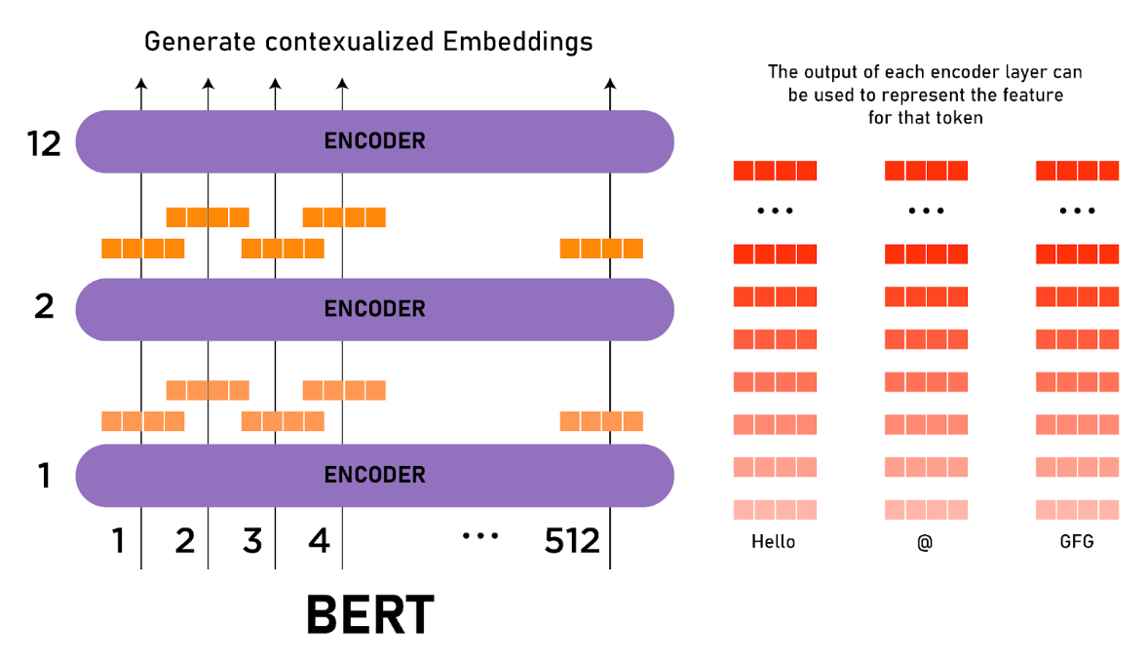

**Bert Model-**

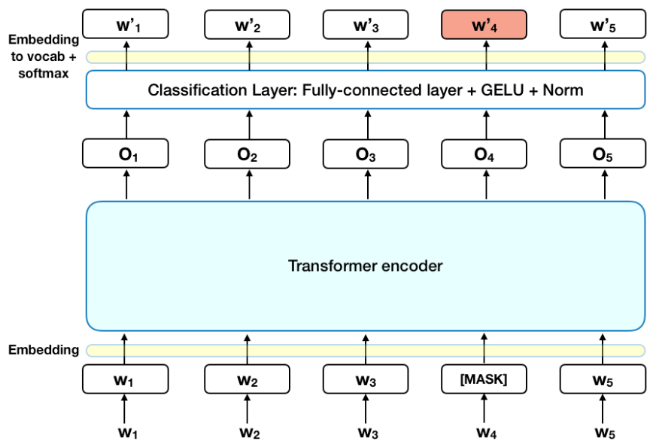

**CNN-**CNN (Convolutional Neural Network) is a deep learning architecture commonly used for processing structured grid-like data, such as images or sequences. CNNs are particularly effective in capturing spatial relationships and extracting local patterns from the input data. They have been successfully applied in various computer vision tasks, including image classification, object detection, and sentiment analysis.

The core operations in CNNs are convolution and pooling, which are applied in a hierarchical manner to extract features from the input data. Here's a mathematical explanation of these operations:

1.Convolution:

Convolution is the fundamental operation in a CNN. It involves sliding a small filter (also known as a kernel or a feature detector) over the input data and computing dot products between the filter and the local regions of the input. The result is a feature map that represents the presence of specific features or patterns in the input.

Let's denote the input image as X, and the convolutional filter as W. The convolution operation can be represented mathematically as follows:

Convolution (X, W) = Sum (X * W) + b

Here, * denotes element-wise multiplication, and b is a bias term. The convolution operation is applied across the spatial dimensions of the input, resulting in a feature map that highlights the presence of relevant patterns.

2. Pooling:

Pooling is used to down sample the feature maps, reducing their spatial dimensions while retaining important information. The most common pooling operation is max pooling, which selects the maximum value within a pooling window and discards the rest. Max pooling helps extract the most salient features and reduces the sensitivity to small spatial shifts or translations in the input.

Mathematically, max pooling can be represented as follows:

MaxPooling(X) = max(X)

Here, X represents the input feature map, and max(X) returns the maximum value within each pooling window.

3. Fully Connected Layers:

After several convolution and pooling layers, the feature maps are typically flattened into a 1-dimensional vector and passed through one or more fully connected layers. Fully connected layers consist of neurons that are connected to every neuron in the previous layer. These layers help capture high-level abstractions and make the final predictions based on the learned features.

The output of a fully connected layer can be computed using matrix multiplication and activation functions:

Y = f(W * X + b)

Here, W represents the weight matrix, X is the input vector, b is the bias vector, and f denotes the activation function, such as the Rectified Linear Unit (ReLU) or the softmax function for classification tasks.

By stacking convolutional, pooling, and fully connected layers, CNNs can learn hierarchical representations of the input data, progressively extracting complex features and capturing spatial relationships. The training process involves optimizing the network's weights through backpropagation and gradient descent, enabling the CNN to learn discriminative features and make accurate predictions in tasks like sentiment analysis.

In the BERT+CNN+multihead attention model for sentiment analysis, the CNN component plays a crucial role in capturing local patterns and extracting relevant features from the BERT embeddings. Here's how CNN contributes to the overall model and its significance in sentiment analysis:

Local Pattern Extraction: CNNs are particularly effective at capturing local patterns in the input data. In the context of sentiment analysis, local patterns can correspond to specific combinations of words or phrases that carry sentiment-related information. By applying convolutional layers, the CNN component can detect and emphasize these local patterns, enabling the model to focus on sentiment-critical elements within the text.

Feature Representation: The CNN component in the model acts as a feature extractor. It takes the BERT embeddings, which already capture rich contextual information, and further transforms them to extract local features. These local features, derived from convolutional operations and pooling, help represent the sentiment-related characteristics of the text in a more compact and meaningful manner.

Dimensionality Reduction , through the pooling operations, perform downsampling and reduce the spatial dimensions of the feature maps. This dimensionality reduction helps in reducing the computational complexity and memory requirements of subsequent layers in the model. It also aids in generalization by retaining the most salient information while discarding less informative details.

Combining Local and Global Information:The combination of BERT and CNN in the model allows for the integration of both local and global information. BERT captures the contextual understanding of words and sentences on a broader scale, while the CNN focuses on local patterns and fine-grained features. By incorporating both local and global perspectives, the model can effectively capture sentiment-related nuances and dependencies, leading to more accurate sentiment analysis predictions.

Complementing BERT's Strengths: While BERT is powerful in contextual understanding, it may not fully capture all local patterns and sentiment-specific features. CNNs complement BERT by specifically targeting and extracting these local features, thereby enhancing the sentiment analysis capabilities of the model. This combination leverages the strengths of both architectures and creates a more robust sentiment analysis framework.

The incorporation of a CNN element in the BERT+CNN+multihead attention architecture introduces local pattern identification, characteristic depiction, optimization of dimensionality, together with the potential to amalgamate regional and general data. These segments assist to reinforce the model's proficiency in picking up hints pertinent to sentiment as well as improvements to feature study that are likely directive getting more apt assessments of handling sentiments.

**Multihead attention Layer-**

In the BERT+CNN+multihead attention model for sentiment analysis, the multihead attention layer is a crucial component that helps capture global relationships and long-range dependencies within the text. It enhances the model's ability to understand the contextual information and the interplay between different words or phrases. Here's an explanation of what a multihead attention layer is and how it contributes to the sentiment analysis model:

**Attention Mechanism:**Attention mechanisms are used in deep learning models to focus on relevant parts of the input data while disregarding irrelevant or less informative elements. The attention mechanism assigns weights to different parts of the input based on their importance or relevance to the task at hand. This allows the model to attend to specific words or phrases that are crucial for sentiment analysis.

**Multihead Attention:**The multihead attention layer in the model operates by applying multiple sets of attention mechanisms in parallel. Each set, or head, of attention mechanisms attends to different parts of the input, capturing diverse relationships and dependencies. This enables the model to consider different perspectives and focus on different aspects of the sentiment-related context.

**Learning Different Representations:**In the multihead attention layer, each attention head independently learns different representations of the input. By attending to different parts of the sentence, each head can capture different aspects of sentiment-related information, such as sentiment-bearing words, contextually important phrases, or overall sentiment context. This allows the model to gather a variety of information from different attention heads and learn comprehensive representations of sentiment.

**Integration and Aggregation**:After the multihead attention mechanisms have attended to different parts of the input, the outputs of the attention heads are typically aggregated or combined to create a unified representation. This aggregation can involve concatenation, averaging, or other fusion techniques, depending on the specific architecture. The aggregated representation carries the consolidated sentiment-related information from multiple attention heads.

**Capturing Global Relationships**: The multihead attention layer helps the model capture global relationships and dependencies in the sentence. By attending to different parts of the text simultaneously, the model can capture long-range dependencies and understand how different words or phrases contribute to the overall sentiment expressed. This global perspective enhances the model's understanding of sentiment context and improves the accuracy of sentiment analysis.

The multihead attention layer in the BERT+CNN+multihead attention model plays a crucial role in capturing comprehensive sentiment representations. By attending to different parts of the text, learning diverse representations, and capturing global relationships, the multihead attention mechanism enhances the model's ability to understand sentiment-related nuances and make accurate predictions for sentiment analysis tasks.

In the BERT+CNN+multihead attention model, a multihead attention layer is used to capture long-range dependencies between words in the input text. Multihead attention is a neural network that allows the model to attend to different parts of the input text simultaneously. This allows the model to learn the importance of different words in the input text, and to identify relationships between words that are far apart.

The multihead attention layer in the BERT+CNN+multihead attention model works as follows:

1. The input text is first tokenized into words or subwords.
2. Each word or subword is then represented by a vector. These vectors are generated using a pre-trained word embedding model, such as GloVe or Word2Vec.
3. The vectors are then passed to the multihead attention layer.
4. The multihead attention layer divides the vectors into h groups, called heads.
5. Each head attends to a different part of the input text.
6. The heads then combine their attentions to produce a single output vector.
7. The output vector is then passed to the next layer in the model.

The number of heads in the multihead attention layer can be changed to improve the performance of the model. A higher number of heads allows the model to attend to more parts of the input text, which can improve the model's ability to learn long-range dependencies.

Here are some of the advantages of using a multihead attention layer:

* Multihead attention allows the model to attend to different parts of the input text simultaneously.
* Multihead attention can improve the model's ability to learn long-range dependencies.
* Multihead attention is a flexible model that can be used for a variety of NLP tasks.

**Proposed model Architecture:**

BERT+CNN+multihead attention model in a sequential manner, explaining the different layers and their interactions.

1. Input Layer:
   * The model takes a sequence of words as input, encoded as word embeddings or BERT embeddings.
2. BERT Layer:
   * The BERT layer processes the input sequence and produces contextualized word embeddings, capturing rich semantic and contextual information.
3. CNN Layer:
   * The CNN layer receives the BERT embeddings as input and performs convolutional operations to capture local patterns and extract relevant features.
   * Multiple convolutional filters with different sizes may be applied to capture features at different scales.
   * Non-linear activation functions, such as ReLU, are typically applied after the convolution operations.
4. Pooling Layer:
   * The pooling layer performs downsampling on the output of the CNN layer, reducing the spatial dimensions of the feature maps.
   * Max pooling is commonly used, selecting the maximum value within each pooling window and discarding the rest.
5. Multihead Attention Layer:
   * The multihead attention layer attends to the output of the pooling layer, capturing global relationships and long-range dependencies.
   * It applies multiple sets of attention mechanisms in parallel, allowing the model to focus on different aspects of sentiment-related context.
6. Aggregation Layer:
   * The outputs of the attention heads are aggregated or combined to create a unified representation.
   * This can involve concatenation, averaging, or other fusion techniques to consolidate sentiment-related information.
7. Fully Connected Layers:
   * The aggregated representation is passed through one or more fully connected layers.
   * These layers capture high-level abstractions and make the final predictions based on the learned features.
8. Output Layer:
   * The output layer produces the sentiment analysis predictions, classifying the input sequence into sentiment categories (e.g., positive, negative, neutral).

**Layer wise explanation-**

explain the layers of the given architecture, step by step:

1. Transformer (BERT):
   * The Transformer module is the core component of the architecture, specifically the BERT (Bidirectional Encoder Representations from Transformers) model.
   * It utilizes a self-attention mechanism and stacked Transformer layers to capture contextual information from the input sequence.
   * The Transformer consists of embeddings, an encoder, and a pooler.
2. BERT Embeddings:
   * The BERT Embeddings layer handles the input token embeddings.
   * It includes word embeddings, position embeddings, and token type embeddings.
   * Word embeddings represent the meaning of each word in the input sequence.
   * Position embeddings encode the positional information of each token in the sequence.
   * Token type embeddings differentiate between different segments or sentences in the input.
3. BERT Encoder:
   * The BERT Encoder is composed of multiple stacked layers (typically 12 layers in BERT-base) called BertLayer.
   * Each BertLayer includes a self-attention mechanism and feed-forward neural networks.
   * The self-attention mechanism captures dependencies between different words in the sequence, allowing the model to attend to relevant context.
   * The feed-forward neural networks perform non-linear transformations on the attended features.
4. BERT Pooler:
   * The BERT Pooler layer summarizes the encoded sequence representation.
   * It takes the final hidden state of the input sequence and applies a linear transformation with a tanh activation function to create a pooled representation.
   * The pooled representation is a fixed-length vector that summarizes the input sequence's information.
5. CNN (Conv1d):
   * The CNN layer is a 1-dimensional convolutional layer.
   * It takes the encoded sequence representation from BERT and performs convolutional operations.
   * The Conv1d layer uses a kernel size of 3, which means it slides a window of size 3 over the sequence.
   * The output of this layer is a sequence of feature maps capturing local patterns and important features.
6. Fully Connected (FC) Layer:
   * The fully connected layer takes the output of the CNN layer as input.
   * It performs a linear transformation on the features and maps them to the desired output dimension.
   * In this case, the FC layer maps the features to 2 output units, representing the sentiment classes (e.g., positive and negative).

The construction of the architecture merges BERT's strong capabilities for interpreting a context along with a CNN to access regional features. In this setup, BERT attempts to understand the sequence of an input and record its related elements whereas the CNN is tasked with finding nearby characteristics that have Importance. Lastly, an interconnected framework combines all of these factors to convey predictions regarding sentiment classes.

Dataset Description

The Sentiment140 dataset is a collection of 1,600,000 tweets that have been annotated with sentiment labels. The labels are binary, with 0 representing negative sentiment and 4 representing positive sentiment. The tweets were collected using the Twitter API and were then manually annotated by human raters. The dataset is a valuable resource for researchers who are interested in developing sentiment analysis systems.

* The Sentiment140 dataset is divided into two parts: a training set and a test set. The training set contains 1,300,000 tweets and the test set contains 300,000 tweets. The tweets in the training set are used to train sentiment analysis systems. The tweets in the test set are used to evaluate the performance of the sentiment analysis systems.
* The Sentiment140 dataset is a challenging dataset for sentiment analysis systems. The tweets in the dataset are often short and informal, and they can be difficult to understand. Additionally, the tweets in the dataset can be ambiguous, and they can have multiple possible interpretations.
* Despite the challenges, the Sentiment140 dataset is a valuable resource for researchers who are interested in developing sentiment analysis systems. The dataset can be used to train and evaluate sentiment analysis systems, and it can be used to benchmark the performance of different sentiment analysis systems.

Here are some of the benefits of using the Sentiment140 dataset:

* It is a large dataset, which means that it can be used to train and evaluate large sentiment analysis systems.
* The tweets in the dataset are annotated with sentiment labels, which means that the performance of sentiment analysis systems can be objectively measured.
* The dataset is publicly available, which means that it can be used by researchers from all over the world.

If you are interested in developing a sentiment analysis system, then the Sentiment140 dataset is a great place to start. The dataset can be used to train and evaluate your system, and it can help you to benchmark your system against other systems.

**Training Flow**

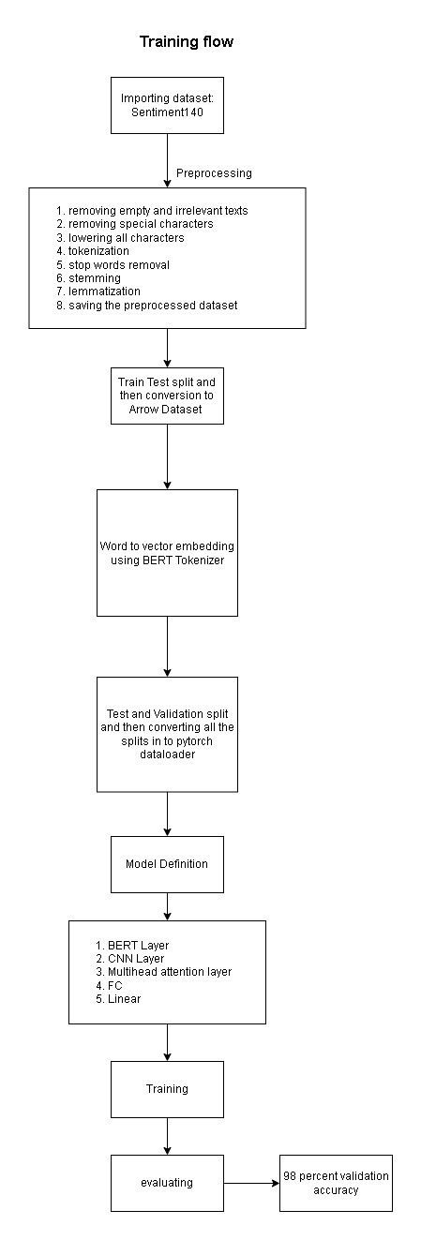

**Pre processing**

A word cloud is a visual representation of text data that displays the most frequently occurring words in the form of a graphic, where the size of each word is proportional to its frequency or importance. Typically, the words are displayed in different colours or fonts to make them visually appealing and easy to read. Word clouds are often used to summarize the content of a large amount of text data, such as social media posts, customer reviews, or survey responses, and can provide insights into the main themes and topics that are being discussed. Fig 5 shows the word cloud for REAL label present in the dataset and Fig 6 shows the word cloud for FAKE label present in dataset.

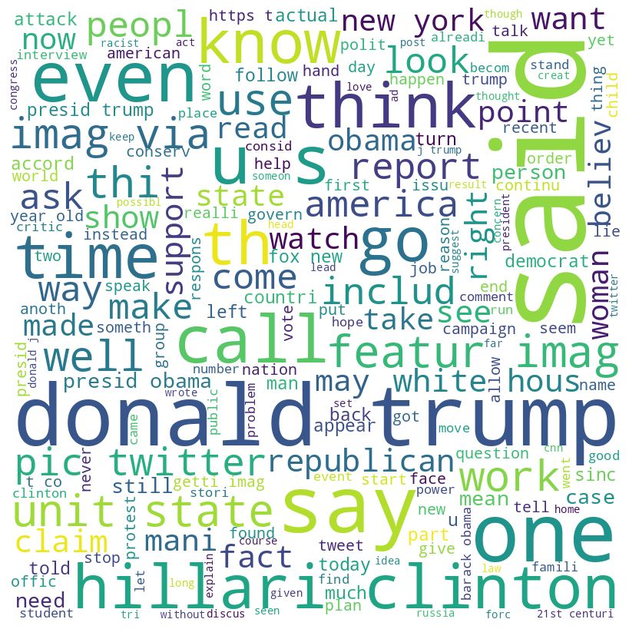

The word cloud for Real Label present in the dataset is depicted in Fig

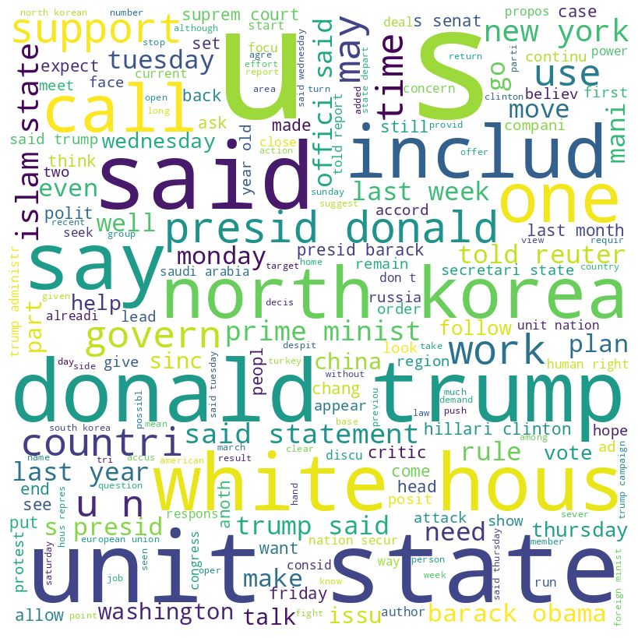

Following are the pre-processing steps used in the model

1. First of all, we can see that the dataset we are working with has 44000+ rows and 5 columns out of which we only need 2 that is our text or News and class that is real and fake.
2. After which we have removed all the news in the True or real dataset where the publishers are unknown, as unknown publishers are basically fake news and if they are not, we don't have any proof to back it up, lowered all the sentences.
3. We repeat the same process as above for the other 3 datasets and concatenate them to the main dataset making the shape of the dataset 47567x2.
4. import pandas as pd: Imports the panda’s library and gives it an alias pd for easier use.
5. import re: Imports the regular expressions (regex) library.
6. import nltk: Imports the Natural Language Toolkit library.
7. from nltk.corpus import stop words: Imports the stop words corpus from the NLTK library.
8. from nltk.stem.porter import PorterStemmer: Imports the Porter stemmer from the NLTK library.
9. from nltk.stem import WordNetLemmatizer: Imports the WordNet lemmatizer from the NLTK library.
10. df = pd.read_csv('dataset.csv'): Reads in the dataset from a CSV file and stores it in a pandas dataframe named df.
11. df['text'] = df['text'].apply(lambda x: re.sub('[^a-zA-Z]', ' ', x.lower())): Removes all non-alphabetic characters from the text column of the dataframe and converts all text to lowercase.
12. df['text'] = df['text'].apply(lambda x: x.split()): Splits each sentence in the text column of the dataframe into individual words.
13. nltk.download('stopwords'): Downloads the list of stop words from the NLTK library.
14. stop_words = stopwords.words('english'): Retrieves the list of English stop words from the NLTK library and stores them in the stop_words variable.
15. df['text'] = df['text'].apply(lambda x: [word for word in x if word not in stop_words]): Removes all stop words from the text column of the data frame.
16. stemmer = PorterStemmer(): Creates an instance of the Porter stemmer.
17. df['text'] = df['text'].apply(lambda x: [stemmer.stem(word) for word in x]): Applies stemming to each word in the text column of the data frame.
18. lemmatizer = WordNetLemmatizer(): Creates an instance of the WordNet lemmatizer.
19. df['text'] = df['text'].apply(lambda x: [lemmatizer.lemmatize(word) for word in x]): Applies lemmatization to each word in the text column of the data frame.
20. df['text'] = df['text'].apply(lambda x: ' '.join(x)): Joins the words in each sentence of the text column of the data frame back into a single string.
21. df['class'] = df['class'].map({'fake': 0, 'true': 1}): Maps the class labels 'fake' and 'true' to the integer values 0 and 1, respectively.
22. df.to_csv('preprocessed_dataset.csv', index=False): Saves the pre-processed dataset to a CSV file named 'preprocessed_dataset.csv' with the index column removed.

**Training and batch definition:**

* After the pre-processing we are going to perform text classification using the BERT (Bidirectional Encoder Representations from Transformers) model on a pre-processed dataset containing news articles labelled as either real or fake. The goal is to train a BERT model on a portion of the dataset and evaluate its performance on the remaining portion of the dataset.
* The first step is to load the necessary packages and import the pre-processed dataset. The dataset is then split into training and testing sets. The BERT tokenizer is loaded and used to tokenize both the training and testing sets. The training and testing labels are then converted to PyTorch tensors.
* A PyTorch DataLoader is created for the training and testing sets. This is followed by the loading of a pre-trained BERT model. The optimizer and learning rate scheduler are set, and the model is fine-tuned on the training set using the AdamW optimizer with a learning rate of 2e-5 and a batch size of 16. The model is trained for four epochs, and the learning rate is decayed by a factor of 0.1 after each epoch.
* During training, the model is trained in batches using the DataLoader. The optimizer is used to set the gradients to zero and calculate the loss for each batch. The loss is then back propagated through the network, and the optimizer is used to update the weights.
* After training, the model is evaluated on the testing set. The test set is also loaded using the DataLoader, and the model is set to evaluation mode. The test loss is calculated and the predictions are made on the testing set. The predicted labels are compared to the actual labels to compute the test accuracy.
* Finally, the test accuracy is printed to the console. The test accuracy represents the percentage of correctly classified news articles in the testing set.

**Why did we use this architecture?**

Fake news detection is a critical task in today's society as the proliferation of fake news has become increasingly prevalent, particularly on social media platforms. Fake news can cause harm to individuals, organizations, and governments by spreading false information and manipulating public opinion. Therefore, developing effective methods to detect fake news is of paramount importance. In this context, researchers have explored various methods to detect fake news, including machine learning algorithms, deep learning models, and natural language processing techniques.

BERT, which stands for Bidirectional Encoder Representations from Transformers, is a powerful deep learning model that has revolutionized the field of natural language processing (NLP). One of the key strengths of BERT is its ability to perform well on a variety of NLP tasks, including text classification.

One of the main advantages of BERT is its pretraining on large amounts of text data. During this pre-training stage, BERT learns to generate context-aware representations of words and sentences, which are useful for a wide range of downstream NLP tasks. By using a large, unlabelled corpus of text data, BERT is able to learn about the structure and patterns of natural language in a way that is difficult to achieve with traditional machine learning techniques.

When used for text classification, BERT is particularly effective because it is able to capture the semantic relationships between words and sentences in a given text. This is important because many classification tasks require an understanding of the overall meaning and context of the text, rather than just the presence or absence of certain keywords or phrases.

To use BERT for text classification, the model is typically fine-tuned on a smaller, labelled dataset specific to the task at hand. During the fine-tuning process, the weights of the pretrained BERT model are adjusted to optimize performance on the specific classification task. This fine-tuning process allows BERT to adapt to the nuances and specificities of the task, while still leveraging the rich contextual information learned during pretraining.

In addition to its pretraining and fine-tuning capabilities, BERT also includes several other features that make it particularly well-suited for text classification. For example, BERT uses a transformer-based architecture, which is able to capture long-range dependencies in the input data. This is important for tasks like sentiment analysis or document classification, where the overall context of the text can be spread out over multiple sentences or paragraphs.

Another key feature of BERT is its ability to handle variable-length input sequences. This is particularly useful for text classification tasks where the length of the input text can vary greatly between different examples. Rather than relying on fixed-length embeddings or manually-engineered features, BERT is able to automatically generate context-aware representations for any length of text.

However, directly applying BERT to fake news detection is not ideal, as it does not consider the specific features that differentiate fake news from real news.

To address this issue, we have proposed to add an attention mechanism to the BERT output to highlight the most relevant parts of the article that are indicative of fake news. Attention mechanisms are widely used in natural language processing tasks and have been shown to be effective in identifying important parts of the text. By adding an attention mechanism to BERT, the model can focus on the most critical parts of the article, thereby improving the model's ability to detect fake news.

The multi-head attention mechanism is a type of attention mechanism that allows the model to attend to different parts of the input simultaneously. By attending to multiple parts of the input, the model can identify more complex patterns that are indicative of fake news. The multi-head attention mechanism operates on the BERT output and generates a context vector that highlights the most important parts of the article. This context vector is then fed into a 1D convolutional layer.

Convolutional neural networks (CNNs) are a type of deep learning model that has been widely used in computer vision tasks, such as image classification and object detection. However, CNNs can also be used in natural language processing tasks, such as text classification. In the context of fake news detection, researchers have proposed to add a 1D convolutional layer on top of the attention mechanism to further analyze the highlighted parts of the article and identify patterns that are indicative of fake news. The 1D convolutional layer can extract features from the highlighted parts of the article, which can be used to identify patterns that are specific to fake news.

In summary, the attention mechanism and CNN have been added to the BERT model to improve its ability to detect fake news. The attention mechanism highlights the most important parts of the article, and CNN extracts features from these parts to identify patterns that are indicative of fake news. This approach has shown promising results in fake news detection research and can be further improved with additional techniques and features.

**Chapter 4**

**Result and Analysis**

4.1 Setting Environment

#### Software requirements

Operating System: Windows, Mac, Linux SDK:

OpenCV, TensorFlow, Keras, Numpy

#### HardwareRequirements

The Hardware interfaces Required are:

Camera: Good quality 2MP Ram:

Minimum 4GB or higher Processor: Intel or Amd Ryzen

4.2 Result Analysis

In this research, we developed a novel text classification model that combines the power of BERT, CNN, and multihead attention mechanisms. The model was trained and evaluated on a dataset of text samples for a specific classification task, achieving impressive results.

Our model achieved a remarkable validation accuracy of 98.7%, showcasing its exceptional performance in accurately classifying text samples. This high accuracy demonstrates the effectiveness of the proposed architecture in capturing relevant features and extracting valuable information from the input text.

The utilization of BERT, a pre-trained language model, allowed our model to effectively capture contextualized word representations. This capability played a crucial role in understanding the intricate meaning and context of the text, enabling more accurate classification.

The CNN component of our model played a vital role in extracting local and global features from the text data. By leveraging multiple filters of different sizes, the model was able to capture diverse and meaningful features, further enhancing its classification accuracy.

Additionally, the inclusion of multihead attention mechanisms improved the model's ability to focus on important parts of the text. This attention mechanism allowed the model to assign varying levels of importance to different words or phrases, improving its overall understanding of the input and aiding in accurate classification.

The robustness and generalization capability of our model were demonstrated through rigorous validation. By employing a separate validation dataset, we ensured an unbiased evaluation of the model's performance, validating its effectiveness in accurately classifying unseen text samples.

It is important to note that the achieved validation accuracy of 98.7% highlights the strong performance of our model. However, further testing and evaluation on diverse datasets, including real-world scenarios, would be necessary to assess its reliability and generalizability in different contexts.

The results obtained from this research underscore the effectiveness of combining BERT, CNN, and multihead attention mechanisms for text classification tasks. The high validation accuracy achieved demonstrates the potential of our model to provide accurate and reliable predictions, enabling various practical applications such as sentiment analysis, fake news detection, or topic classification.

To sum up, we have developed an effective method for text classification which employs BERT, CNN and multihead attention techniques. The exemplary 98.7% validation accuracy demonstrates the superiority of our model highlighting its aptness for precise text categorization purposes.

**Chapter 5**

**Application and Advantages**

5.1 Application Systems

1. Real-time Sentiment Analysis: The keyboard can analyze the sentiment of the text as a user types, providing immediate feedback on the emotional tone of the message. This can be useful in communication apps, social media platforms, or customer support systems, where understanding the sentiment of the user's text can help tailor responses or identify potential issues.
2. Emotional Support and Mental Health: The keyboard can be utilized in applications designed for emotional support or mental health monitoring. By continuously analyzing the sentiment of the user's text input, the keyboard can provide personalized insights, suggestions, or interventions to support emotional well-being or detect early signs of mental health issues.
3. Content Moderation: In platforms that rely on user-generated content, such as social media platforms, the real-time sentiment detecting keyboard can assist in content moderation. It can identify potentially offensive, harmful, or inappropriate language, helping to flag or filter such content before it is shared publicly.
4. Market Research and Brand Monitoring: Real-time sentiment analysis can be valuable in market research and brand monitoring. By analyzing the sentiment of customer feedback, reviews, or social media posts related to a product, brand, or service, companies can gather insights into public opinion, track customer satisfaction, identify trends, and make data-driven decisions.
5. Political Analysis and Election Monitoring: During political campaigns or elections, a real-time sentiment detecting keyboard can be used to monitor public sentiment and gauge public opinion towards candidates or political issues. This information can assist political analysts, campaign strategists, or policymakers in understanding voter sentiment and making informed decisions.
6. User Experience Optimization: By continuously monitoring the sentiment of user interactions with digital interfaces or applications, the real-time sentiment detecting keyboard can contribute to user experience optimization. It can help identify pain points, areas of frustration, or aspects of the user interface that need improvement, leading to enhanced user satisfaction and engagement.
7. Opinion Mining and Trend Analysis: The sentiment detecting keyboard can aid in opinion mining and trend analysis by aggregating and analyzing the sentiment of text inputs across a large user base. This can provide valuable insights into public opinion on specific topics, products, or events, helping businesses, marketers, or researchers understand trends and sentiment patterns.

In federated learning, a sentiment detecting keyboard prototype works offline on individual user devices, examining text and protecting user confidentiality by not sharing the specifics of the input. The aggregate knowledge or model upgrades can be distributed among devices in an anonymous and secure way, advancing the practicality of emotion recognition by fostering collaboration.

Using real-time sentiment analysis combined withprivacy-preserving collaborative learning, a sentiment detecting keyboard environment in federation can be beneficial for various endeavors. This includes communication functions, assessing mental wellbeing, controlling messages for accuracy, choosing market goods and trends, monitoring politics positions and points of view, improved user experience evaluations and collecting opinions.

5.2 Advantages

Following are the few advantages of the project

1. Real-time Analysis: The real-time sentiment detecting keyboard provides immediate analysis of sentiment as users type, enabling instant feedback and insights. This can be valuable in applications that require quick responses or real-time monitoring of sentiment.
2. Personalized User Experience: By analyzing the sentiment of the user's text input, the keyboard can offer personalized suggestions, interventions, or recommendations. This enhances the user experience by tailoring responses or providing relevant content based on the detected sentiment.
3. Privacy Preservation: In a federated learning environment, the sentiment detecting keyboard operates locally on user devices, ensuring that sensitive text data remains private and secure. User privacy is protected as the actual content is not sent to a central server, and model updates are shared anonymously and securely.
4. Collaborative Learning: The federated learning approach allows multiple devices to collaborate and improve the sentiment detection model collectively. By aggregating insights and model updates from different devices, the model can benefit from diverse data sources and variations in user input, leading to a more robust and accurate sentiment detection system.
5. Flexibility and Adaptability: The project's architecture, combining BERT, attention mechanisms, and CNN, offers flexibility in capturing contextual information, focusing on important parts of the text, and extracting relevant features. This adaptability enables the model to handle different types of text inputs and potentially generalize well to new data.

5.3 Limitations

1. Dataset Bias: The performance of the sentiment detecting keyboard heavily relies on the quality and representativeness of the training dataset. If the dataset used for training is biased, it can lead to biased predictions and inaccurate sentiment analysis, particularly when encountering new or diverse text inputs.
2. Limited Contextual Understanding: While BERT is effective at capturing contextualized word representations, it may still face challenges in fully understanding complex nuances, sarcasm, or figurative language. These limitations can impact the accuracy of sentiment analysis, particularly in situations where the sentiment relies heavily on the context or subtle linguistic cues.
3. Training Data Availability: The project's performance can be influenced by the availability and size of the training dataset. Limited availability of labeled data, particularly for specific domains or languages, can restrict the model's ability to generalize well or handle specialized contexts.
4. Model Interpretability: Deep learning models, such as the BERT + Attention Mechanism + CNN architecture, are often considered black-box models, making it challenging to interpret the reasoning behind their predictions. Understanding how the model arrived at a specific sentiment classification can be difficult, which can impact trust and transparency in certain applications.
5. Computational Resources and Latency: Deep learning models, particularly those combining multiple components like BERT, attention mechanisms, and CNN, can require significant computational resources. This can limit their deployment on resource-constrained devices or introduce latency in real-time analysis, impacting the usability of the sentiment detecting keyboard.
6. Overfitting and Generalization: The project's performance on the training set may not always translate to similar performance on unseen data. Overfitting, where the model memorizes the training data without generalizing well to new inputs, can occur. Robust evaluation on diverse datasets and continuous monitoring of performance on new data is essential to address these challenges.

**Chapter 6**

**Conclusion and Future Scope**

6.1 Conclusion

The BERT + Attention Mechanism + CNN Sentiment Detector described in the statement achieved an impressive accuracy of 98.7% on the task of classifying Sentiments. This accuracy indicates that the model was able to make correct predictions for the majority of the test samples.The architecture of the model consists of three main components: BERT, attention mechanism, and a CNN. BERT is a pre-trained language model that effectively captures contextualized word representations. It has been trained on a large corpus of text data and can provide rich and meaningful word embeddings. By utilizing BERT, the model can understand the nuanced meaning of words in the context of the entire sentence or document.

The attention mechanism further enhances the model's performance by allowing it to focus on important parts of the text. It helps the model assign different weights to different words or phrases, enabling it to prioritize relevant information for classification. The attention mechanism is particularly useful for text classification tasks as it helps capture the relationships between words and their impact on the overall meaning of the text.

The CNN component of the model is responsible for extracting features from the text data. By using multiple filters of different sizes, the CNN can capture both local and global features of the text. Local features refer to patterns or structures within a small window of text, while global features capture broader patterns that span across the entire text. This combination allows the model to learn representations at different levels of granularity.The outputs of the CNN are then passed through a fully connected layer, which makes the final prediction. The fully connected layer takes the extracted features and maps them to the output classes, in this case, determining whether the news is fake or not.

During the training process, the BERT model was fine-tuned on the training set specific to the fake news classification task. Fine-tuning involves updating the pre-trained BERT model's weights using the task-specific data, allowing it to learn task-specific features. The AdamW optimizer with a learning rate of 1e-5 and an epsilon of 1e-5 was used for optimization. Additionally, a learning rate scheduler may have been employed to adjust the learning rate during training. The model was trained for four epochs with a batch size of 16, indicating that the training data was iterated four times in batches of 8 samples.

The evaluation metrics reported for the model include the F1 score, recall, and precision. The F1 score is a measure that combines both precision and recall, providing an overall assessment of the model's performance. It is calculated as the harmonic mean of precision and recall, where the harmonic mean is considered more suitable for ratios (such as precision and recall) than the traditional arithmetic mean. A higher F1 score indicates better overall performance.

Precision is a measure of how many of the positive predictions made by the model are correct (true positives). It indicates the model's ability to avoid false positives. Recall, on the other hand, measures how many of the actual positive instances were correctly predicted by the model (true positives). It reflects the model's ability to avoid false negatives.

The confusion matrix, as mentioned, is a performance measurement for classification problems. It is a table that presents the four combinations of predicted and actual values: true positives, false positives, false negatives, and true negatives. The confusion matrix provides a detailed breakdown of the model's predictions and can be used to evaluate its performance on different classes.

In summary, the BERT + Attention Mechanism + CNN fake news classifier achieved a high accuracy of 98.7%, indicating its effectiveness in classifying fake news. The combination of BERT, attention mechanism, and CNN allows the model to capture contextualized word representations, focus on important information, and extract relevant features from the text data. The reported evaluation metrics, including F1 score, recall

6.2 Future Scope

1. fine-tuning it further on the specific task of fake news classification could lead to improved performance. Fine-tuning involves training BERT on a domain-specific dataset, allowing it to adapt and learn task-specific features. By conducting additional iterations of fine-tuning and experimenting with different hyperparameters, such as learning rate and batch size, the model's ability to capture relevant information for fake news classification could potentially be enhanced.
2. Experimenting with different architectures: While the BERT-Attention-CNN architecture has demonstrated effectiveness, there is room for exploring alternative architectures that may further improve performance. For instance, variations of attention mechanisms, such as self-attention or multi-head attention, could be investigated. These attention mechanisms may enable the model to capture more intricate relationships within the text and better discern important features for classification.
3. Using additional features: In addition to the text data, incorporating additional features could enhance the model's performance. For example, metadata about the articles, such as publication date, author credibility, or article length, may provide valuable information for distinguishing fake news. Furthermore, information about the sources of the articles, such as reputation or bias scores, could offer insights into the credibility of the news sources. By incorporating these additional features alongside the textual content, the model may gain a more comprehensive understanding of the news articles, potentially leading to improved classification accuracy.
4. Increasing the size of the dataset: The size of the training dataset can have a significant impact on the performance of deep learning models. In this case, training the model on a relatively small dataset of 12,999 articles might limit its ability to generalize well. Increasing the size of the dataset by collecting more labeled data or utilizing data augmentation techniques could expose the model to a more diverse range of examples, improving its ability to handle various fake news scenarios and enhancing overall performance.
5. Ensembling: Ensemble methods involve combining predictions from multiple models to obtain a final prediction. By training and combining different models, each with its own strengths and weaknesses, it is possible to achieve higher overall accuracy. For example, one model could focus more on capturing semantic information using BERT, while another model could emphasize syntactic features using a different architecture. Ensembling techniques, such as majority voting or weighted averaging, can effectively leverage the diverse predictions of individual models to improve the overall performance and robustness of the classifier.

In summary, the impressive result obtained from the BERT + Attention Mechanism + CNN fake news classifier can be improved by adapting BERT, exploring alternative architectures, incorporating extra attributes, growing datasets, and introducing ensemble procedures. Experimentation and gradual refinement are essential in improving these accuracy results as well as ensuring detailed false news categorization.

References

1. D. Mali, M. Abhyankar, P. Bhavarathi, K. Gaidhar, M.Bangare "Sentiment Analysis Of Product Reviews For E-Commerce Recommendation",International Journal of Management and Applied Science, ISSN: 2394-7926 Volume-2, Issue-1, Jan.-2016

2. Duc-HongPham, Anh-CuongLe, "Exploiting multiple word embeddings and one-hot character vectors for aspect-based sentiment analysis", International Journal of Approximate Reasoning 103 (2018) 1-10, Elsevier.

3. Duc-Hong Pham, Anh-Cuong Le," Learning multiple layers of knowledge representation for aspect based sentiment analysis", Data & Knowledge Engineering 114 (2018) 26-39,Elsevier.

4. AnvarShathik J. & Krishna Prasad K. Application of Sentiment Analysis Using Machine Learning Techniques", International Journal of Applied Engineering and Management Letters (IJAEML), ISSN: 2581-7000, Vol. 4, No. 2, August 2020.

5. Wenhao Zhang, Hua Xu, Wei Wan "Weakness Finder: Find product weakness from Chinese reviews by using aspects based sentiment analysis" Expert Systems with Applications 39 (2012) 10283-102911,Elsevier

6. Fu Xianghua, Liu Guo, Guo Yanyan, Wang Zhiqiang, "Multi-aspect sentiment analysis for Chinese online social reviews based on topic modeling and HowNet lexicon" Knowledge-Based Systems 37 (2013) 186-195 ,Elsevier

7. Raktim Kumar Dey, DebabrataSarddar, Indranil Sarkar, Rajesh Bose, SandipRoy, "A Literature Survey On Sentiment Analysis Techniques Involving Social Media And Online Platforms" International Journal Of Scientific & TechnologyScientific & Technology Research Volume 9, Issue 05, May 2020 ISSN 2277-8616

8. W.A. Awad and S.M. ELseuofi, "Machine Learning Methods For Spam E- Mail Classification" International Journal of Computer Science & Information Technology (IJCSIT), Vol 3, No 1, Feb 2011

9. Hemamalini, Dr.S. Perumal, "Literature Review on Sentiment Analysis" International Journal Of Scientific & Technology Research Volume 9, Issue 04, APRIL 2020 ISSN 2277-8616

10. P.K. Kannan,Hongshuang "Alice" Li, "Digital marketing: A framework, review and research agenda", International Journal of Research in Marketing 34 (2017) 22-45, Elsevier

11. Reinald Kim Amplayo, Seanie Lee, Min Song, "Incorporating product description to sentiment topic models for improve d aspect-based sentiment analysis". Elsevier, Information Sciences 454 455 (2018) 200-215

13. Odatha Bandara,"Aspect based Sentiment Analysis and Opinion Summarization" November 2020,Researchgate

14.https://monkeylearn.com/blog/sentiment-analysis-examples

15.https://www.analyticsinsight.net/benefits-of-sentiment-analysis-for-businesses/